AI PROJECT REPORT

Water Jug Problem Solver With Three Jugs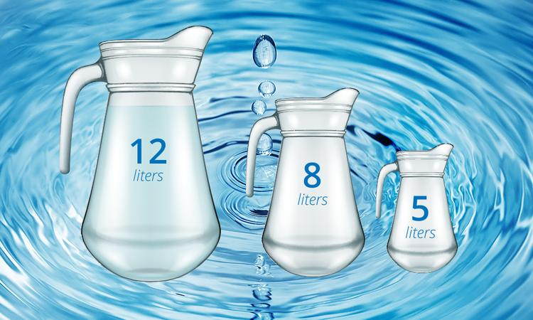

Submitted By:

P.Naveen Chandu.

11805079

Submitted To:

Ankita Wadhawan Mam

Objective:the main objective of this project is that we have solved the questions based on water jug with 2 jugs.But in this we will try to solve the water jug problem with 3 jugs.

METHODOLOGY

1.giving input of the states

2.generating states

3.printing the states in between

These three sections done by P.NaveenChandu(11805079)

**Problem: Given 3 jugs of capacites: 12, 8 and 5 litres. Our 12 L jug is completely filled. Using these 3 jugs split the water to obtain exactly 6 Litres.**

**ALGORITHM:**

**I used DFS to search through all the states of the jugs. At each state, we’ll have certain choices of emptying water from one jug into another. We’ll try each choice, calling our function for each state, and if we reach the goal state, we stop.**

SCREENSHOTS OF OUTPUT:

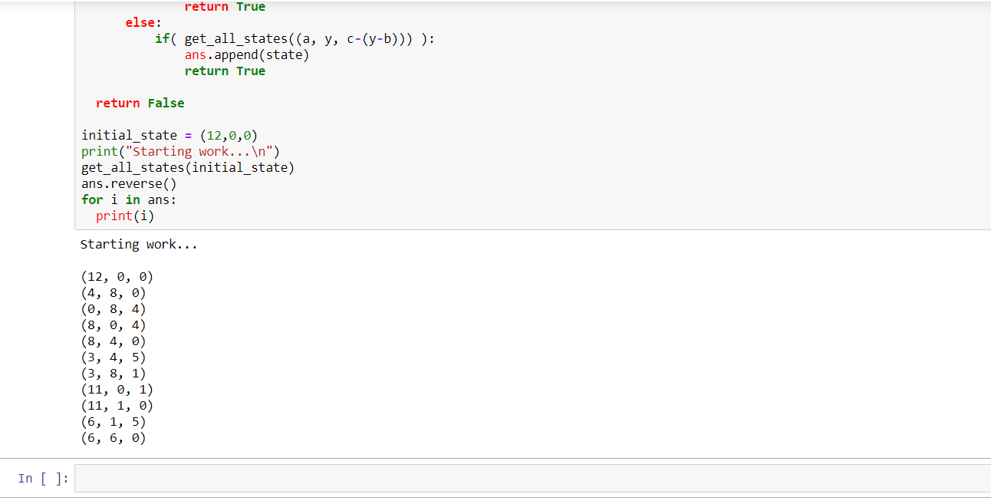

Here we generated the in between states of from initial state(12,0,0)

To goal state(6,6,0).

RESULT:

What ever the result we have expected is came as output that is (6,6,0).

THANK YOU MAM